**Project Title:** Formatting Windows and Installing Linux Operating System

**Objectives:**

* This project is to understand how to create a bootable media for Linux installation
* This project is to learn the process of installing Linux on a computer
* This project is to understand basic installation set up and configuration

**Methodology:**

Step 1: First I am downloading Linux ISO file from web browser. Linux have many distros like Ubuntu, Red hat, Fedora, Kali Linux but I am choosing Ubuntu here.

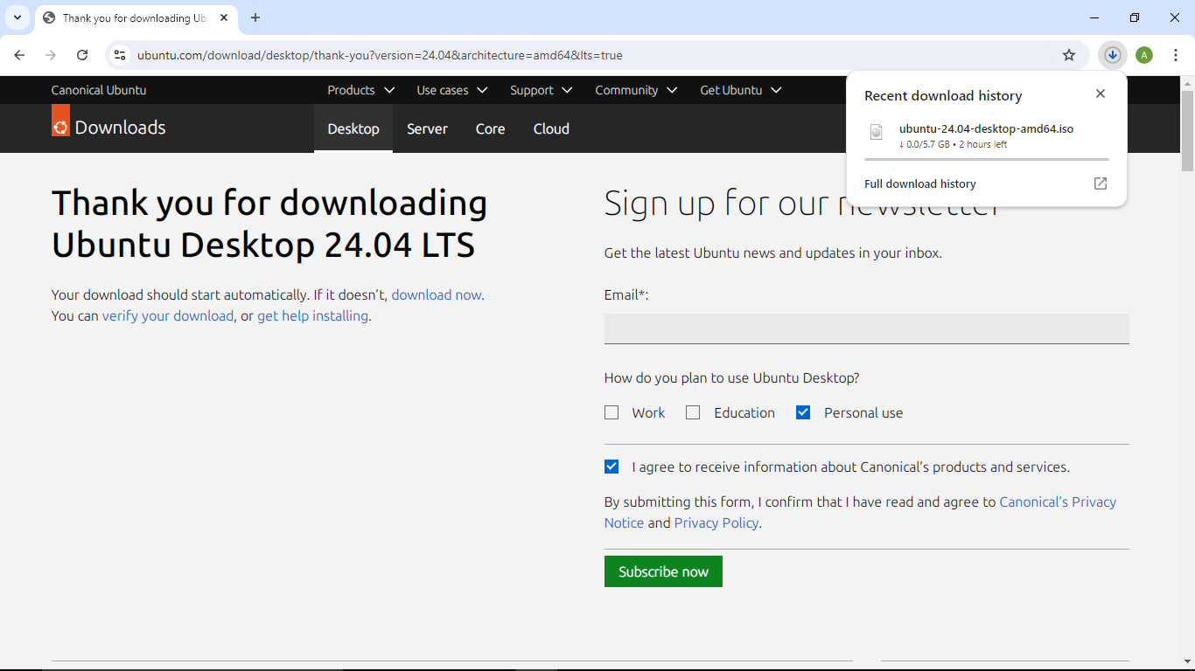

Step 2: Next I am downloading Rufus tool from web browser. Rufus is a free, open-source utility for Microsoft Windows that helps us format and create bootable USB flash drives.

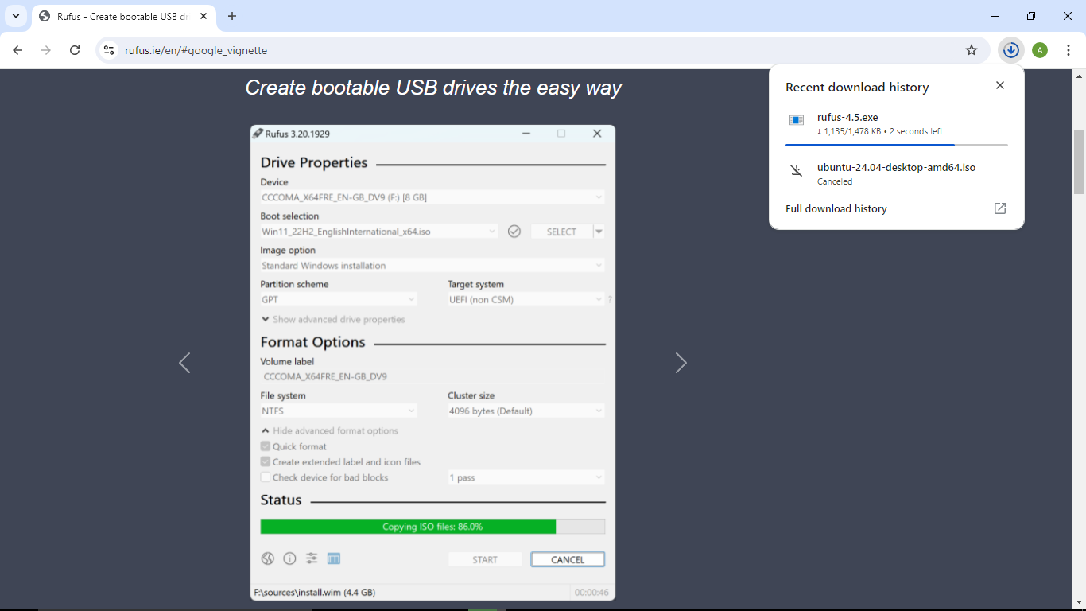

Step 3: Now I will make my USB Drive bootable using Rufus. First, I have inserted my USB Drive in my computer system and open Rufus tool.

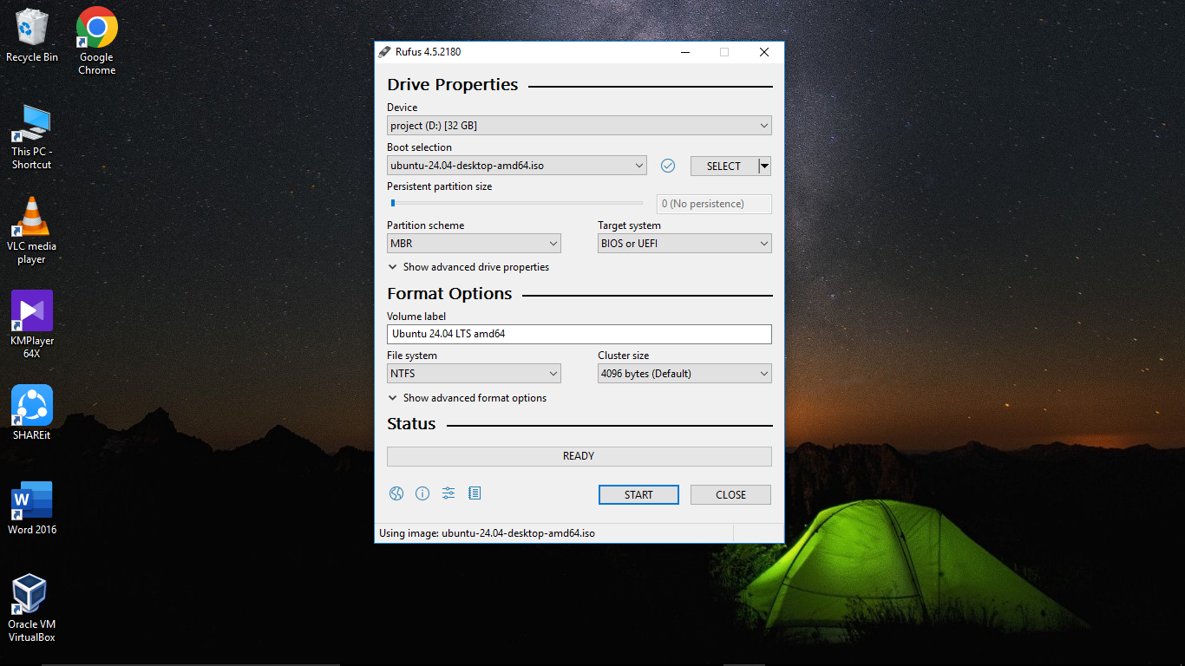

First, I have selected my USB Drive in device section. Next, I have selected the ISO file of Linux in Boot Selection option. Here I have chosen MBR in partitioning scheme because MBR support both BIOS or UEFI (Modern BIOS). Next, I have chosen NTFS as filesystem because NTFS include many features like encryption, faster access speed, security. And finally, everything is set so now I have to click on start.

Step 4: Now I have to change the Boot order in BIOS. So, for that I have entered into BIOS by pressing F2 or F12 or Del key after restarting my computer before log in screen loads. Now I am selecting USB Storage Device in Boot order and have to press Enter.

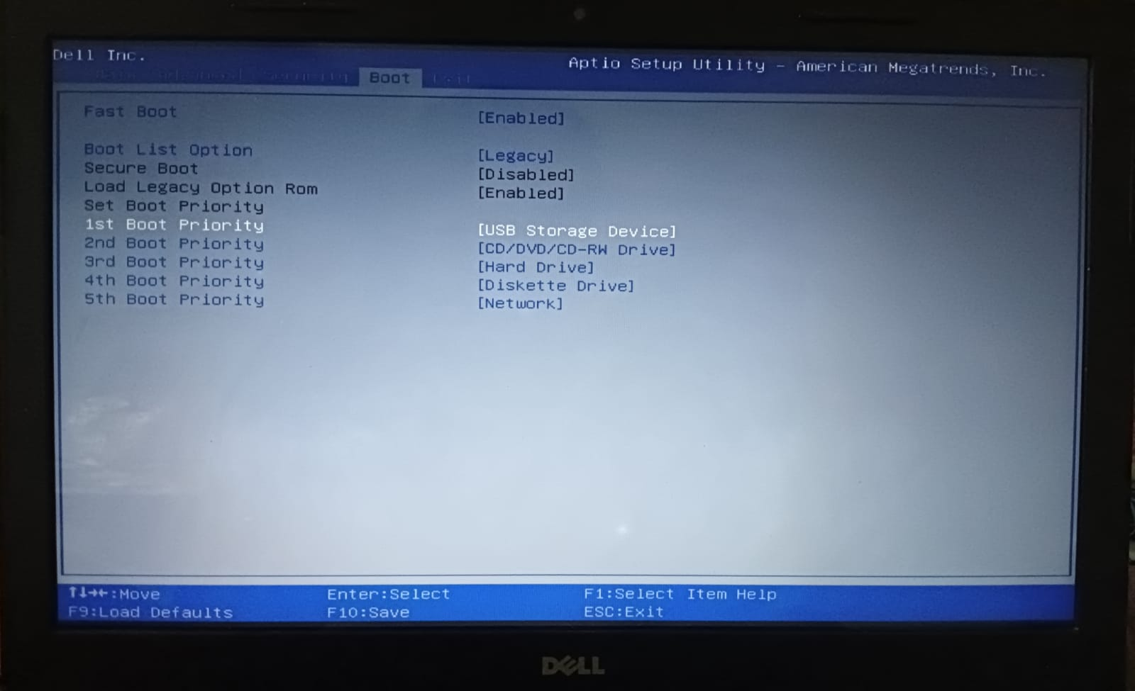

Step 5: Next an interface is appearing for selecting Language.

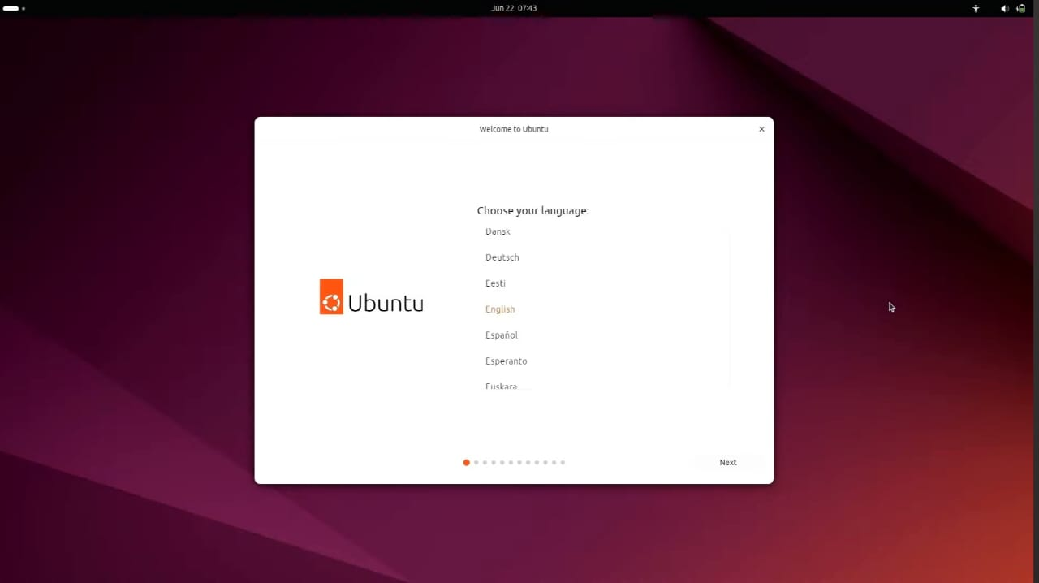

Step 6: Now an interface is appearing for Installing Ubuntu, here I have to click on ‘Install ubuntu’ and click on ‘Next’

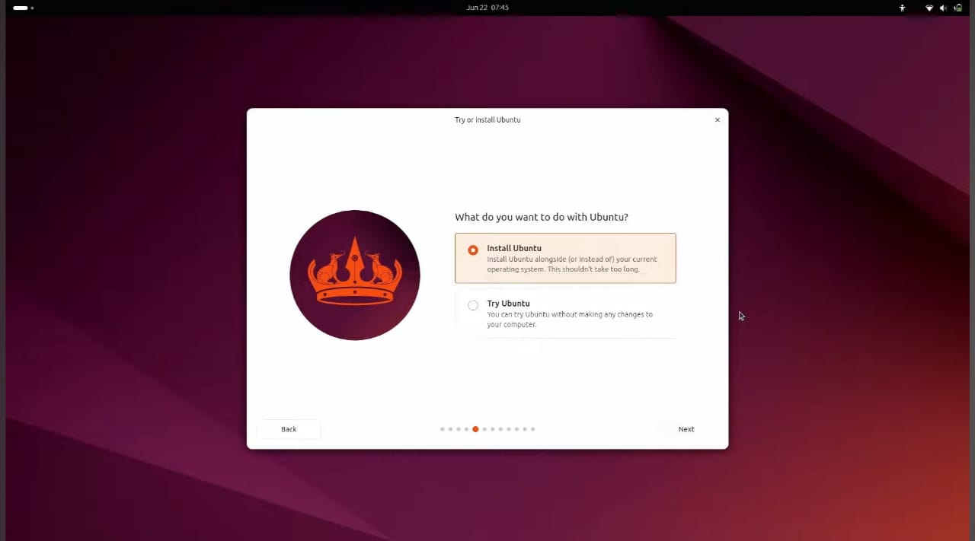

Step 7: Here I want a clean and fresh installation of Ubuntu in my Hard Drive so I am selecting ‘Erase disk and install Ubuntu’ or if I had to make disk partition then I had to select ‘Manual installation’

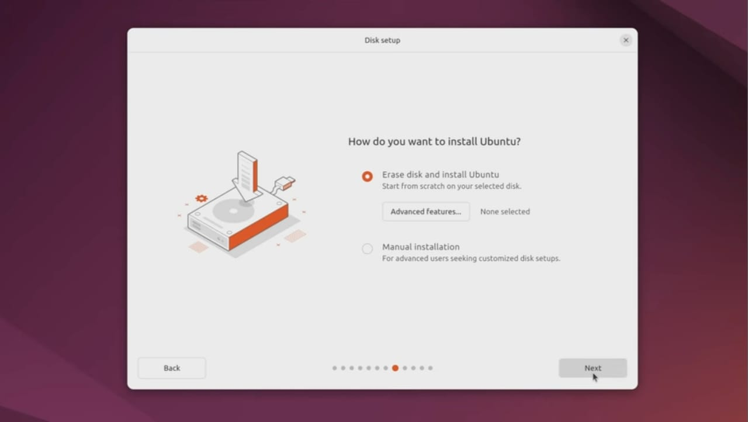

Step 8: Here I have to put my name, computer name, also my username & password.

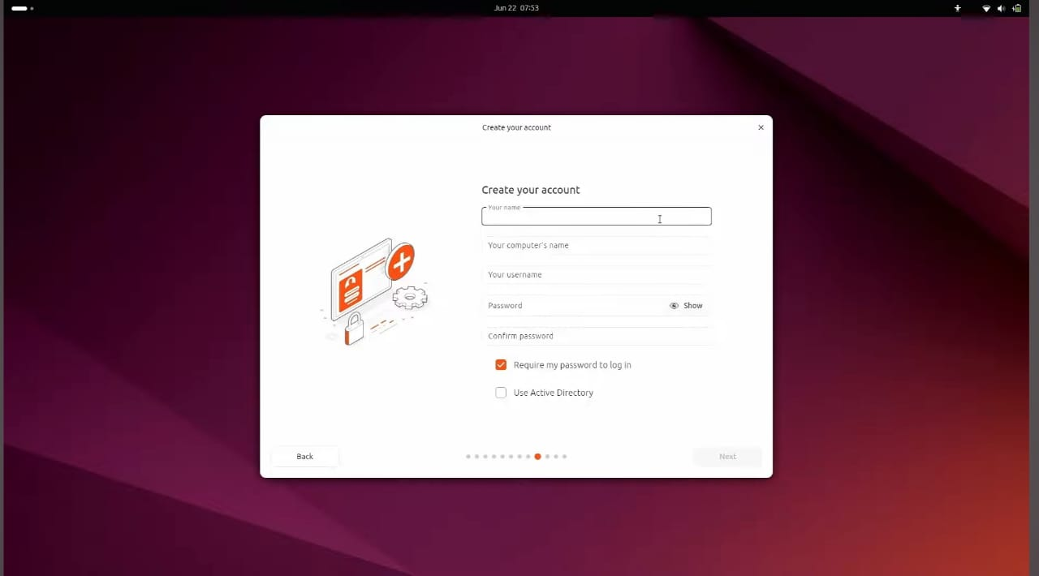

Step 9: Finally, installation start and it will take some time to complete the installation.

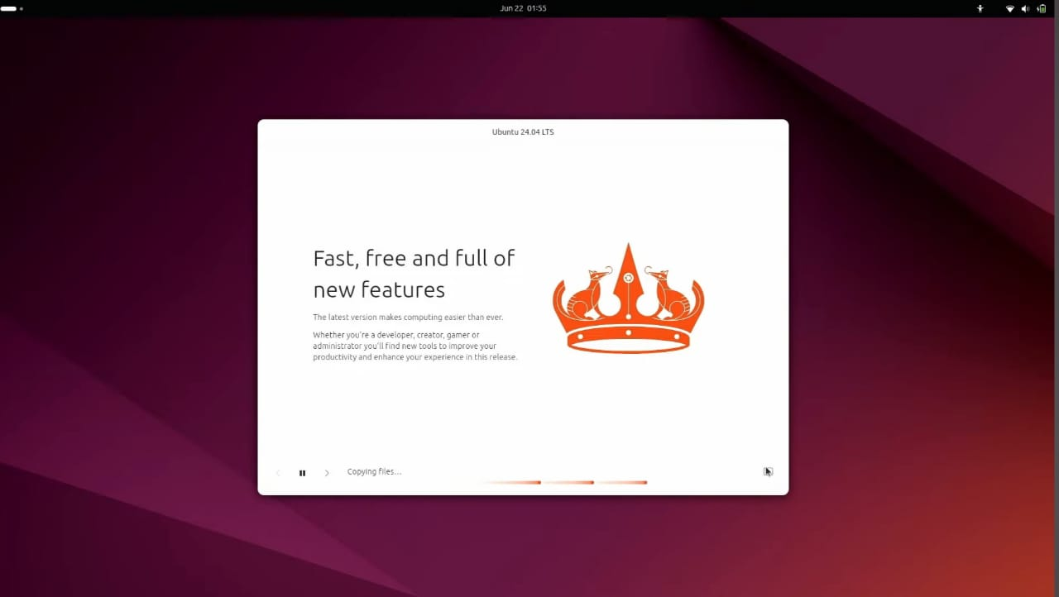

Step 10: Now I have to type my username & password for log in to my system.

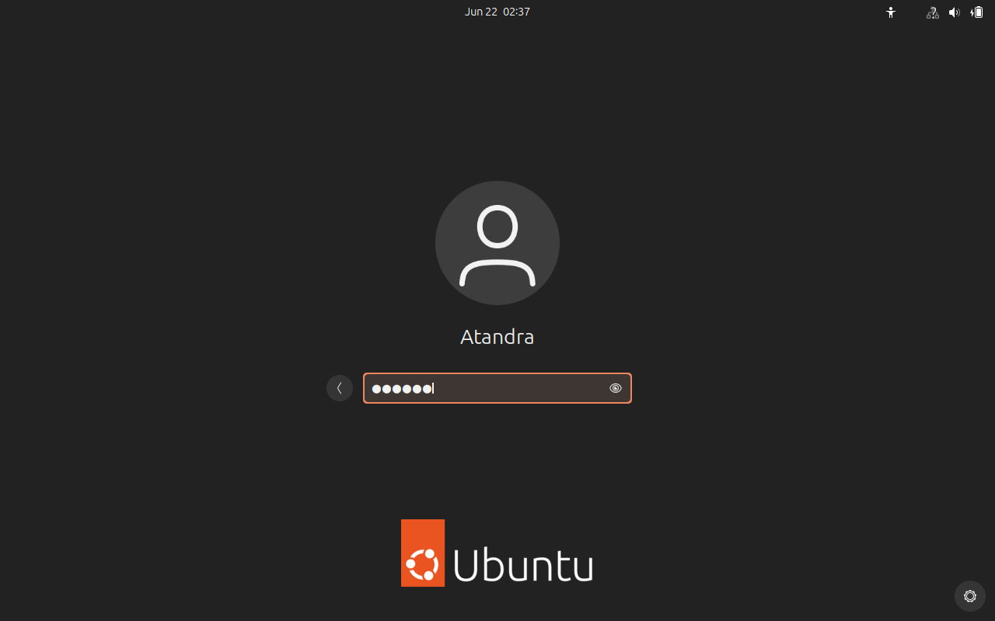

Step 11: Finally, I am logged into my system.

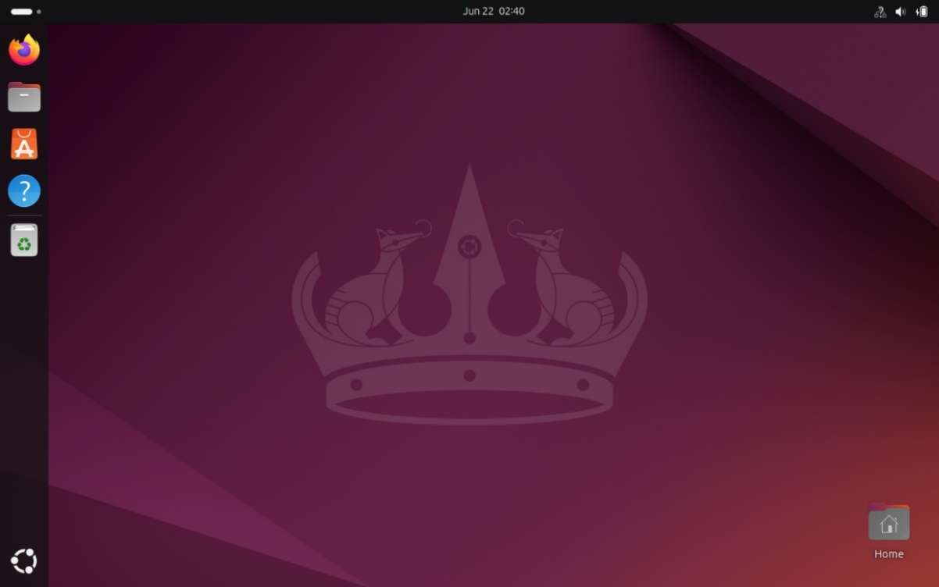

**Conclusion:**

This project has provided a comprehensive guide to installing Linux operating system on a computer. By following this steps user can confidently install the Linux operating system, and optimize their system for performance.

This knowledge is essential for IT professionals to manage their own computer systems.